Week 1 Task
Data Cleaning and Preliminary Analysis with R
Dataset: Titanic Passenger Data
(Source: Kaggle Titanic Competition / publicly hosted CSV)
Prepared by: Shravani Patane
B.E. Artificial Intelligence & Data Science

1. Dataset Overview
The dataset used for this task is the Titanic passenger dataset, a widely used public dataset originally released as part of the Kaggle "Titanic: Machine Learning from Disaster" competition. It records demographic and travel details for 891 passengers aboard the RMS Titanic, along with whether each passenger survived the sinking. The dataset was selected because it naturally contains missing values, a mix of numerical and categorical variables, and enough structure to support meaningful data cleaning and exploratory analysis.

1.1 Variables
Column | Type | Description
PassengerId | Numerical (ID) | Unique identifier for each passenger
Survived | Categorical (0/1) | Survival outcome (0 = No, 1 = Yes) — target variable
Pclass | Categorical (1/2/3) | Ticket / passenger class (proxy for socio-economic status)
Name | Text | Full name of the passenger
Sex | Categorical | Gender of the passenger
Age | Numerical | Age in years (contains missing values)
SibSp | Numerical | Number of siblings/spouses aboard
Parch | Numerical | Number of parents/children aboard
Ticket | Text | Ticket number
Fare | Numerical | Passenger fare paid
Cabin | Categorical | Cabin number (heavily missing)
Embarked | Categorical | Port of embarkation: C, Q, or S (contains missing values)

Dataset dimensions: 891 rows x 12 columns (before cleaning).

2. Loading the Data and Initial Inspection
The dataset was loaded into R using read.csv(), treating both empty strings and the literal string "NA" as missing values. The structure and summary statistics of the raw data were inspected first using str() and summary().
df <- read.csv("titanic.csv", stringsAsFactors = FALSE,
na.strings = c("", "NA"))

str(df)
summary(df)
R Output — str(df):
'data.frame': 891 obs. of 12 variables:
$ PassengerId: int 1 2 3 4 5 6 7 8 9 10 ...
$ Survived : int 0 1 1 1 0 0 0 0 1 1 ...
$ Pclass : int 3 1 3 1 3 3 1 3 3 2 ...
$ Name : chr "Braund, Mr. Owen Harris" "Cumings, Mrs. John Bradley..." ...
$ Sex : chr "male" "female" "female" "female" ...
$ Age : num 22 38 26 35 35 NA 54 2 27 14 ...
$ SibSp : int 1 1 0 1 0 0 0 3 0 1 ...
$ Parch : int 0 0 0 0 0 0 0 1 2 0 ...
$ Ticket : chr "A/5 21171" "PC 17599" "STON/O2. 3101282" "113803" ...
$ Fare : num 7.25 71.28 7.92 53.1 8.05 ...
$ Cabin : chr NA "C85" NA "C123" ...
$ Embarked : chr "S" "C" "S" "S" ...
R Output — summary(df) (key numerical columns):
Age Fare Survived Pclass
Min. : 0.42 Min. : 0.00 Min. :0.0000 Min. :1.000
1st Qu.:20.12 1st Qu.: 7.91 1st Qu.:0.0000 1st Qu.:2.000
Median :28.00 Median : 14.45 Median :0.0000 Median :3.000
Mean :29.70 Mean : 32.20 Mean :0.3838 Mean :2.309
3rd Qu.:38.00 3rd Qu.: 31.00 3rd Qu.:1.0000 3rd Qu.:3.000
Max. :80.00 Max. :512.33 Max. :1.0000 Max. :3.000
NA's :177

3. Handling Missing Values
Missing values were quantified per column using colSums(is.na(df)). The results show three columns with missing data:
Column | Missing Count | Missing %
Cabin | 687 | 77.10%
Age | 177 | 19.87%
Embarked | 2 | 0.22%
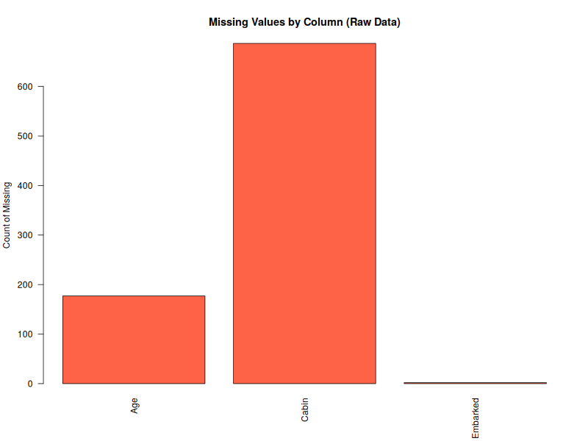
Figure 1: Count of missing values by column in the raw dataset.

3.1 Cleaning Strategy
- Cabin (77% missing): Dropped entirely. With more than three-quarters of values missing, any imputation would introduce more noise than signal, and the column is not essential for the planned analysis.
- Age (19.9% missing): Imputed using the median Age within each Pclass x Sex subgroup, rather than a single global median. This preserves the natural relationship between class/gender and age (e.g. 1st-class passengers tended to be older) instead of flattening the distribution.
- Embarked (0.22% missing, 2 rows): Imputed using the mode (most frequent port), since the count is negligible and the variable is categorical.
- Fare: Checked for missing values as a precaution (median imputation would apply); none were found in this dataset.
df_clean <- df
df_clean$Cabin <- NULL

# Median Age by Pclass + Sex subgroup
age_medians <- aggregate(Age ~ Pclass + Sex, data = df_clean,
median, na.rm = TRUE)
for (i in which(is.na(df_clean$Age))) {
m <- age_medians$Age[age_medians$Pclass == df_clean$Pclass[i] &
age_medians$Sex == df_clean$Sex[i]]
df_clean$Age[i] <- m
}

# Mode imputation for Embarked
mode_val <- names(sort(table(df_clean$Embarked), decreasing = TRUE))[1]
df_clean$Embarked[is.na(df_clean$Embarked)] <- mode_val
R Output — verification after cleaning:
Age missing before imputation: 177
Age missing after imputation: 0
Embarked mode used for imputation: S

PassengerId Survived Pclass Name Sex Age
0 0 0 0 0 0
SibSp Parch Ticket Fare Embarked
0 0 0 0 0

4. Outlier Detection
Outliers in the two continuous variables (Age, Fare) were identified using the IQR (interquartile range) rule: any value below Q1 - 1.5*IQR or above Q3 + 1.5*IQR is flagged as an outlier.
detect_outliers <- function(x) {
q1 <- quantile(x, 0.25); q3 <- quantile(x, 0.75)
iqr <- q3 - q1
lower <- q1 - 1.5 * iqr; upper <- q3 + 1.5 * iqr
sum(x < lower | x > upper)
}
detect_outliers(df_clean$Fare) # Fare outliers
detect_outliers(df_clean$Age) # Age outliers

fare_cap <- quantile(df_clean$Fare, 0.99)
df_clean$Fare_capped <- ifelse(df_clean$Fare > fare_cap,
fare_cap, df_clean$Fare)
Fare outliers: 116
Age outliers : 33
Fare 99th percentile cap applied at: 249.01
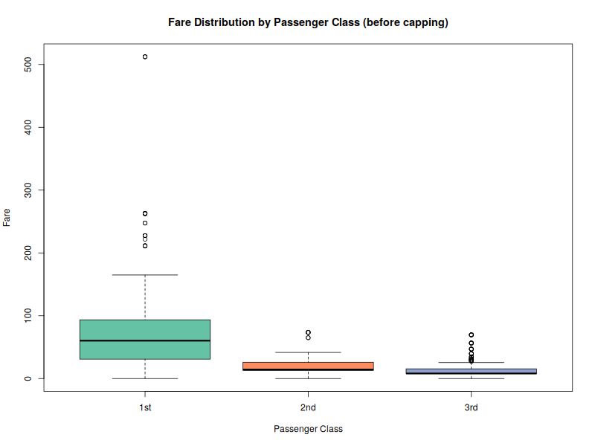
Figure 2: Fare distribution by passenger class (boxplot), showing high-fare outliers concentrated in 1st class.
Fare shows substantial right-skew with 116 IQR-based outliers, mostly high-fare 1st-class tickets — this is expected (a small number of premium/luxury cabins) rather than data-entry error, so instead of removing these rows, Fare was winsorized (capped) at the 99th percentile to reduce the influence of extreme values while retaining all 891 records. Age had 33 outliers, mainly very young children and a few passengers above 65; these were retained unchanged as they are plausible, genuine values.

5. Normalization
Age and the capped Fare were rescaled to a 0-1 range using min-max normalization, producing Age_norm and Fare_norm. Normalization was applied after outlier capping so that a small number of extreme values would not compress the rest of the distribution toward 0.
minmax <- function(x) (x - min(x)) / (max(x) - min(x))
df_clean$Age_norm <- minmax(df_clean$Age)
df_clean$Fare_norm <- minmax(df_clean$Fare_capped)
Age Age_norm Fare_capped Fare_norm
1 22 0.2711737 7.2500 0.02911574
2 38 0.4722292 71.2833 0.28627116
3 26 0.3214375 7.9250 0.03182651
4 35 0.4345313 53.1000 0.21324769
5 35 0.4345313 8.0500 0.03232851

6. Encoding Categorical Variables
- Sex: Label-encoded to a binary numeric column Sex_encoded (male = 1, female = 0), since it has only two categories.
- Embarked: One-hot encoded into three binary indicator columns — Embarked_C, Embarked_Q, Embarked_S — since it is nominal with three unordered categories.
- Pclass: Converted to an ordered factor with labels "1st", "2nd", "3rd" for readability in tables and plots.
- Survived: Also stored as a labeled factor (Survived_label: "No"/"Yes") alongside the original 0/1 numeric column, so it can be used either for statistical modeling or for readable summaries/plots.
df_clean$Sex_encoded <- ifelse(df_clean$Sex == "male", 1, 0)

df_clean$Embarked_C <- as.integer(df_clean$Embarked == "C")
df_clean$Embarked_Q <- as.integer(df_clean$Embarked == "Q")
df_clean$Embarked_S <- as.integer(df_clean$Embarked == "S")

df_clean$Pclass <- factor(df_clean$Pclass, levels = c(1,2,3),
labels = c("1st","2nd","3rd"))
df_clean$Survived_label <- factor(df_clean$Survived, levels = c(0,1),
labels = c("No","Yes"))
Sex Sex_encoded Embarked Embarked_C Embarked_Q Embarked_S
1 male 1 S 0 0 1
2 female 0 C 1 0 0
3 female 0 S 0 0 1
4 female 0 S 0 0 1
5 male 1 S 0 0 1
The fully cleaned, transformed dataset (891 rows x 19 columns) was exported as titanic_cleaned.csv using write.csv(df_clean, "titanic_cleaned.csv", row.names = FALSE).

7. Exploratory Data Analysis

7.1 Age Distribution
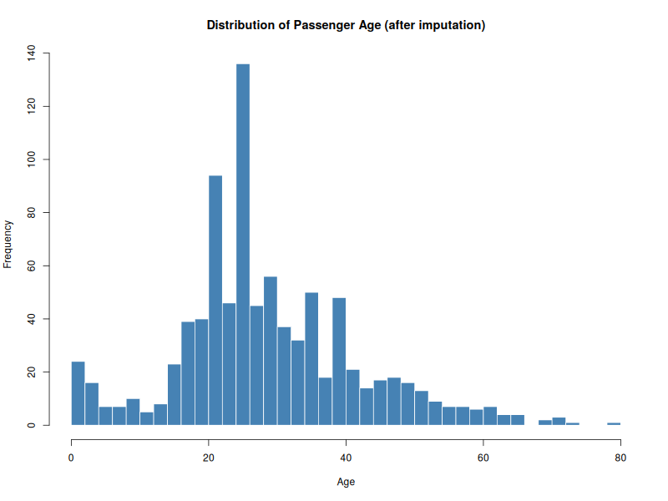
Figure 3: Distribution of passenger age after median imputation.
The age distribution is right-skewed and roughly unimodal, peaking in the 20-30 range, consistent with a passenger population dominated by young to middle-aged adults, with a smaller number of children and older passengers.

7.2 Survival by Sex and Class
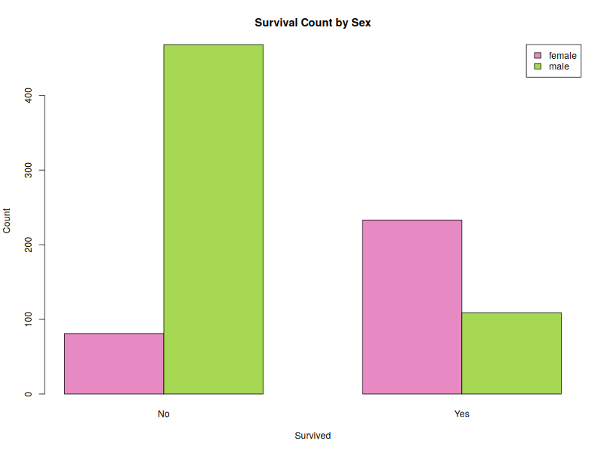
Figure 4: Survival counts split by sex.
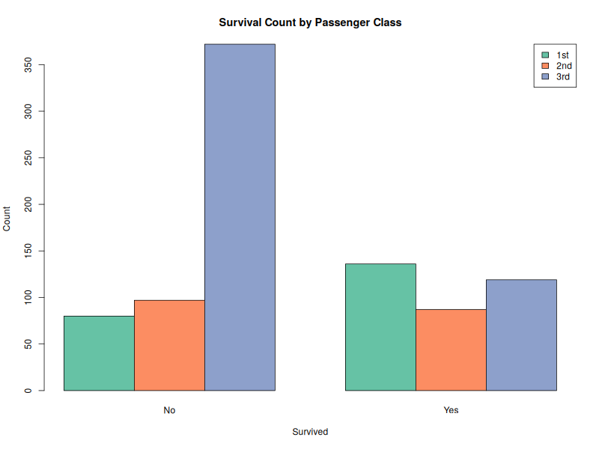
Figure 5: Survival counts split by passenger class.
Cross-tabulated survival rates:
Group | Did Not Survive % | Survived %
Overall | 61.62% | 38.38%
Female | 25.80% | 74.20%
Male | 81.11% | 18.89%
1st Class | 37.04% | 62.96%
2nd Class | 52.72% | 47.28%
3rd Class | 75.76% | 24.24%
Two clear patterns emerge: survival was far more likely for women than men (74.2% vs 18.9%), and survival probability decreased sharply moving from 1st class (63.0%) to 3rd class (24.2%). This is consistent with the historical "women and children first" evacuation protocol and the closer proximity of 1st-class cabins to lifeboats.

7.3 Correlation Analysis
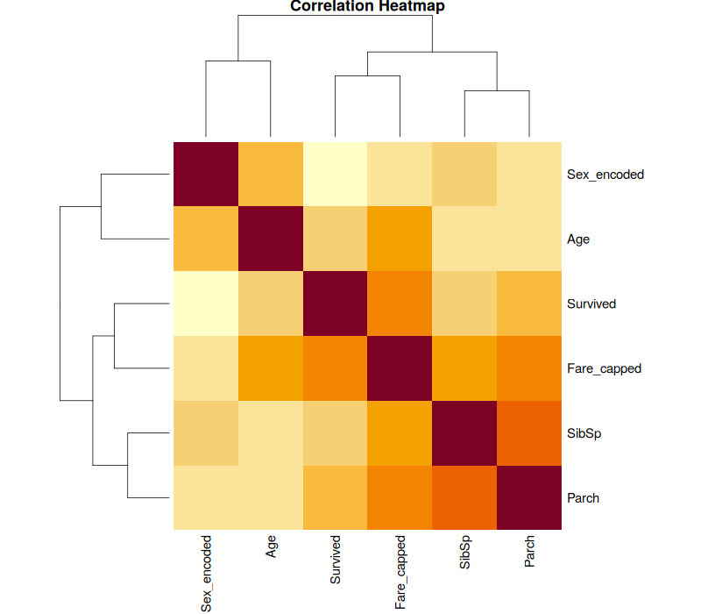
Figure 6: Correlation heatmap of numeric/encoded variables.
num_vars <- df_clean[, c("Survived","Age","Fare_capped",
"SibSp","Parch","Sex_encoded")]
cor_mat <- round(cor(num_vars, use = "complete.obs"), 2)
print(cor_mat)
Survived Age Fare_capped SibSp Parch Sex_encoded
Survived 1.00 -0.06 0.27 -0.04 0.08 -0.54
Age -0.06 1.00 0.13 -0.25 -0.18 0.10
Fare_capped 0.27 0.13 1.00 0.19 0.25 -0.21
SibSp -0.04 -0.25 0.19 1.00 0.41 -0.11
Parch 0.08 -0.18 0.25 0.41 1.00 -0.25
Sex_encoded -0.54 0.10 -0.21 -0.11 -0.25 1.00
Sex_encoded has the strongest correlation with Survived (-0.54), confirming that being male is strongly associated with lower survival. Fare_capped correlates positively with Survived (0.27), reinforcing the class effect seen above (higher fare -> better survival odds). SibSp and Parch correlate moderately with each other (0.41), which makes sense as both describe family size aboard.

8. Key Insights
- Survival was strongly gender-dependent: women survived at nearly 4x the rate of men (74.2% vs 18.9%).
- Passenger class was a strong proxy for survival: 1st-class passengers were roughly 2.6x more likely to survive than 3rd-class passengers.
- Age had only a weak direct correlation with survival (-0.06) once other factors are considered, suggesting sex and class were more decisive than age alone.
- Fare, which is closely tied to class, positively correlated with survival (0.27), reinforcing the socio-economic pattern in outcomes.
- Missing data was concentrated and structured rather than random: Cabin was missing largely for lower-class passengers (fewer had private cabins), and Age was missing somewhat more often for lower classes as well — supporting the choice of Pclass+Sex-based median imputation over a single global median.

9. Tools and Environment
- Language: R (base R only — no external plotting/statistics packages required)
- Key functions used: read.csv(), str(), summary(), aggregate(), quantile(), cor(), hist(), boxplot(), barplot(), heatmap()
- Output files: titanic_cleaned.csv (cleaned/transformed dataset), plots/ (6 exported PNG visualizations), run_log.txt (full console output)

